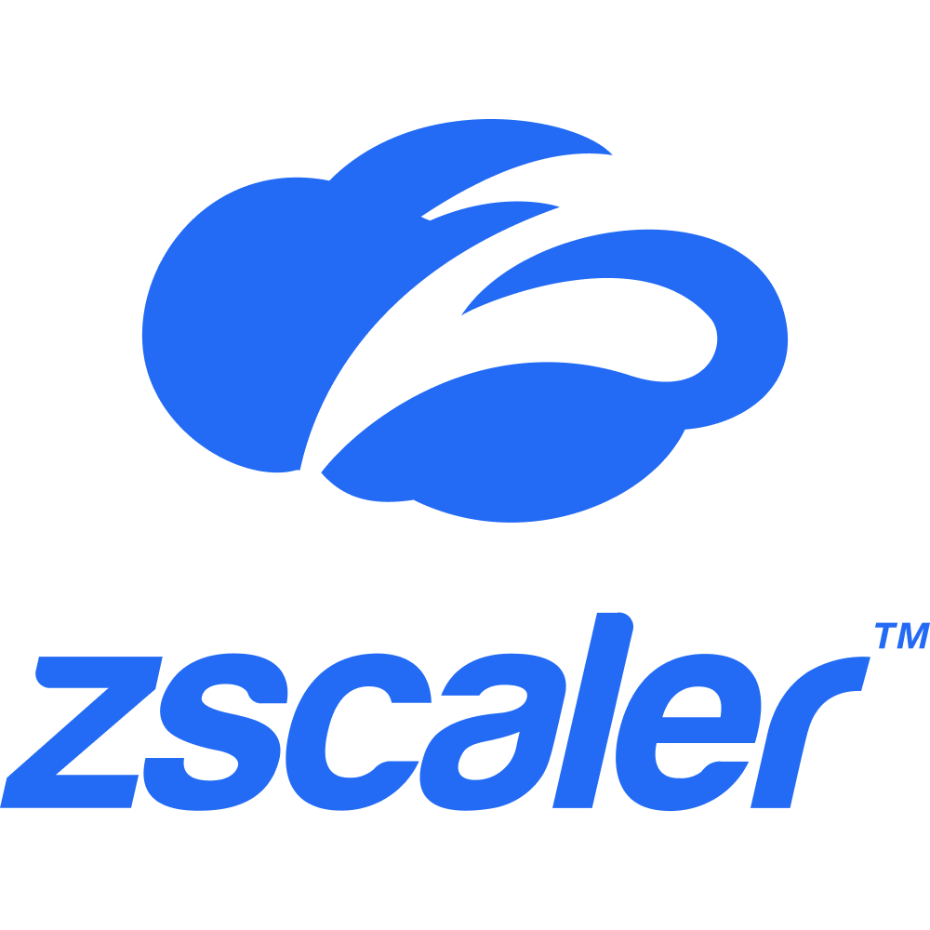

**Joel Meza Rios**

|  |
| --- |
| SUMMARY |

* Around 7 years of experience in the IT field, Network Engineer L2/L3 with expertise in Cisco/Aruba Routing and Switching, troubleshooting of complex network systems. Experience in designing, installing, configuring and maintenance of ISP/Enterprise Networks using Cisco routers, Aruba Switches Stacking, configuring various networking devices. Extensive Experience in WAN Technologies, Switching Technologies along with Failover Mechanisms & Inter VLAN Routing types. Excellent analytical, organizational, problem-solving & resolution skills.
* Experience with Cisco IOS and Aruba Routing and Switching. Configuration & troubleshooting of routing protocols: BGP, OSPF, SDWAN
* Hands on experience for *Cisco Routers:* 2911, ISR4331, and *Cisco L3 Switches*: 3750, *L2 Switches* Cisco: 2960, *Meraki Switches:* MS120, MS125, MS210, *Data Center switch*: Nexus 7000 series, *Aruba L3 Switches*: 3810M, 2930F
* Hands on with Actelis (aggregation devices) used as a high-performance access/transport switches that enable fiber-grade connectivity with low delay over multiple copper pairs or fiber.
* Sound knowledge of Aruba Clearpass, Citrix NetScaler.
* Handling day to day operational tasks on Silverpeak SDWAN/Watchguards, and Palo Alto Firewalls solutions for eg: addition of Vlans, modifications of subnets, ranges allowed from DHCP to end user devices, such as Kiosks, POS, Music players, Menu- boards, etc.
* Experience with Cradlepoint LTE Devices (IBR1700 Series/E3000 Series) for remote locations within the Airport, with zero access to run a fiber or far away from a copper installation. Mainly used to connect end user devices, such as Point of Sale systems, and Clock in/out tablets.
* Hands-on experience in understanding requirement specifications, test procedure and testing Connectivity issues.
* Understanding System Specifications, requirements, and review testcases.
* Generate tickets for issues discovered with detailed information collected.
* Reproduce the issue when there is a need and support issue investigation and retest failed cases which has been fixed.
* Knowledge of implementing and troubleshooting layer 2 technologies such as VLAN Trunks, VTP, 802.1q, Ether channel, STP, RSTP and MSTP.
* Experience with Zscaler Cloud Internet access, managing the usage of data, locations, blockings, Troubleshoot connectivity issues, etc.
* Sound knowledge of Dockers and Kubernetes for DevOps purposes mainly.
* Experience working with Datacenter switches such as the Cisco Nexus and Cisco Catalyst.
* Proficiency in LAN/WAN setup, installation, configuration, and commissioning of network devices.
* Virtuous understanding of networking concepts such as routing protocols, VLANs, IP address management, TCP/UDP Protocols, VTP & Ether Channel.
* Knowledge in OSI model, in depth knowledge and hands on experience on IPV4 addressing, ARP, reverse proxy and ICMP concepts.
* Worked on proposed changes and handling service requests assigned through ticketing systems Global ServiceNow.

|  |
| --- |
| Core Competencies |

* ***Routing***: BGP, OSPF, SDWAN, Static Routing, SNMP, NTP, RADIUS, TACACS, CDP, LLDP.
* ***VPN***: IPSEC/IKEv2.
* ***Cisco Devices:*** *Routers*: 2911, ISR4331 models, *Cisco L3 Switches*: 3750, *L2 Switches* Cisco: 2960, *Meraki Switches:* MS120, MS125, MS210, *Aruba L3 Switches*: 3810M, 2930F

*Datacenter switches****:*** Nexus 7000 series.

* ***Operating Systems***: Windows 7/8/10, Linux (CentOS, Fedora, RedHat, Kali Linux).
* ***Switching****:* STP, PVST+, RPVST+, VTP, Inter VLAN Routing & Multi-Layer Switch, Ether Channels (PAGP, LACP), HSRP, VRRP.
* ***Tools*:** Actelis (aggregator), Service Now, Core and Encore ticketing systems

Network Tools: Wire Shark, Cisco packet tracer, GNS3, SolarWinds, Citrix SDWAN, Microsoft Visio.

* **Security Technologies:** Armor Anywhere, Akamai/Imperva WAF, Crowdstrike, etc.

|  |
| --- |
| Experience |

## Network Security Engineer

## *Rackspace Technology, [Jan 2023 – Present]*

*New Jersey, United States*

## *Multiple Clients (Private and Public Sector) – I am not allowed to disclose their names.*

## Configuring VLANs and assign it accordingly with their respective device.

## Provisioning of devices, such as switches, routers mainly.

## Assistance in placing security devices, such as Palo alto, ASA firewalls, WAF devices like Imperva, and IDS devices.

## Setting up the VPNs to establish the communication with DUO M2F and other vendors.

## To establish technical calls/meetings as required and involve all relevant teams/vendors/account managers, etc.

## Ensure the infrastructure is working as expected with some monitoring platform such as Solarwinds.

## Raising cases/requests depending on the needs.

## Attending in a fast fashion to deliver a quality service by using calls mainly but also chats and emails.

## Monitor performance and ensure systems are protected from the various threats.

## Working on tickets to resolve day to day issues related to Networking Security for Private and Public Cloud customers as a Tier 2 support.

## IDS (Intrusion Detection Systems) and IPS (Intrusion Prevention Systems) management.

## Apply preventive and corrective actions to get rid of threats with the help of the various technologies used to prevent breaches or apply corrective actions to a vulnerable system.

## Performing break/fix actions to an unprotected device from the end user.

## Handling day to day Customer requests for general/specific inquiries.

## Troubleshooting and resolving network security related issues in the shortest possible time.

## Interacting with the customer, understand the requirements and escalate accordingly with other teams.

## Active collaboration between teams.

## Scheduling and follow up of Maintenance Windows for different purposes, e.g., Customer calls to address inquiries/issues, upgrading systems, apply corrective measures, etc.

## Network Engineer

## *Softtek [ Jul 2019 – Jan 2023]*

*Addison, TX - United States*

## *Client: HMSHost*

* Working on customer service requests for new changes and implementation plans.
* Deliver timely changes, migrations, and implementations on a customer network and to create and maintain an outstanding customer experience.
* Studying the design document before implementation and suggesting any changes to technical designers that may cause problems during implementation.
* Configuration and troubleshooting of issues based on connectivity for BGP, OSPF, HSRP, STP, VTP and VLAN.
* Configuring VLAN, trunking and Ether Channel on Cisco switches
* Configuring Router with Sub-interfaces to allow tagged VLAN Traffic.
* Making the Logical and Physical Diagram with the help of Visio.
* Design, Test and Document Network Changes before Implementation and after implementations
* Provisioning of new devices through CLI and remove the configuration of Legacy device to decommission the device.
* Guiding the On-site tech fields during the implementation for installation of network equipment.
* Experience on walking through the user to fix a connectivity issue to their end device.
* To establish technical & business bridges/conference calls as required and involve all relevantteams/vendors/Project Manager and to take ownership of the issue until resolution.
* Installation and configuration of Cisco and Aruba HP routers and switches.
* Provisioning and walk the technician through the process to install Aruba APs.
* Maximizing network performance through ongoing monitoring and troubleshooting
* Worked on a big project to swap Switches from Cisco to Aruba
* Updating network equipment to the latest firmware releases.
* Reporting network status to key stakeholders.
* Prepared changes for Change Advisory Board (CAB).
* Share knowledge (creation of SOP/KT documents with the process to follow and resolve any incident, but also, about new technologies, implementations, etc.)
* On-call rotation support.

***Network Engineer*** ***[Nov 2018 – Apr 2019]***

*Kenergy, Mexico*

* Responsible for maintaining the Network Infrastructure for an extension of the office in Mexico.
* Intermediate knowledge of Grafana dashboard – Constantly monitoring of the nodes in the infrastructure.
* Use of Microsoft Visio for making logical diagrams.
* Management of Cisco devices, such as routers and switches mainly.
* Setup and installation of the various network devices.
* Provisioning of the firewalls (ACLs, VPNs, etc.)
* Updating the firmware of the devices as required.
* Active collaboration between teams.

***IT Help-Desk Support***

***Softtek [Mar 2016 – Dec 2017]***

*Aguascalientes, Mexico*

## *Client: General Electric (GE)*

* Working as part of the Level 1 support for Servers and Network respectively.
* Upgrades of tools hosted on the various versions of Windows Servers (2003, 2008, 2012).
* Telephone/chat/call support to end users.
* Analyze network data (usage, disk space availability, server function).
* Create or revise user instructions, procedures, and manuals.
* Document network support activities through ServiceNow (SNow) ticketing system.
* Basic interaction with Solarwinds for monitoring purposes along with an exclusive tool developed by the Customer.
* Use of Routers and switches Cisco.
* Working along with tech-fields to troubleshoot network connectivity issues.
* On-Call support.

|  |
| --- |
| Education |

**Universidad Tecnologica de Aguascalientes, Mexico**

*Bachelor of Information Technologies, Aug 2017*

*GPA: 4.0/4.0*